**MINISTRY OF ECONOMY**

**UNITED SOCIALIST REPUBLICS**

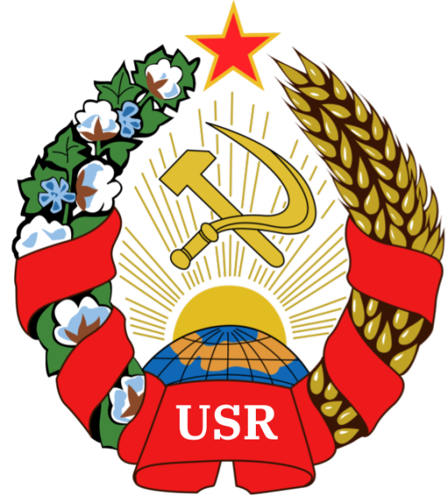

**GUIDE TO UTILIZATION OF THE ALMENDRIAN CREDIT**

**Author:** Comrade GENERAL PRESIDENT TIZIAN ARUNA

**Sponsored by:** The Almendrian AR and the Communist Party of the United Socialist Republics

Hereby releases this document to the public.

# Step 1: Installing Metamask

*For PC:*

1: Have Google Chrome Browser

2: Install the MetaMask Extension - [MetaMask - Chrome Web Store](https://chrome.google.com/webstore/detail/metamask/nkbihfbeogaeaoehlefnkodbefgpgknn?hl=es)

*For Mobile:*Android: [Install the MetaMask App](https://play.google.com/store/apps/details?id=io.metamask&gl=US)

iPhone: [Install the MetaMask App](https://apps.apple.com/us/app/metamask-blockchain-wallet/id1438144202)

# Step 2: Switching to Harmony Mainnet

*For PC:*

Switch the connected blockchain by clicking on the tab saying Main Ethereum Network, we need to add the Harmony One network.  
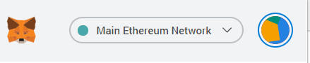  
Scroll down until you find Custom RPC.

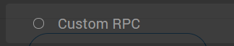

Enter in the Harmony One mainnet settings as follows:

* **Network name:** Harmony Mainnet
* **RPC URL:** [https://api.harmony.one](https://api.harmony.one/)
* **Chain ID:** 1666600000 (shared 0)
* **Currency**: ONE
* **Explorer**: [https://explorer.harmony.one/](https://explorer.harmony.one/#/)

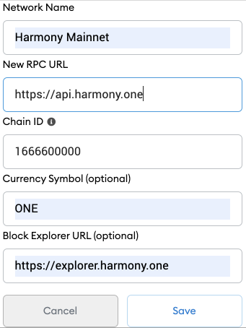

Click **Save**.

*For Mobile:*

Basically the same - but you’ll find the settings in the settings menu instead of “right there”. (I think - idk i don’t use mobile metamask)

# Step 3: Adding Almendrian Credit (DO THIS WITH HARMONY MAINNET INSTEAD OF ETHEREUM MAINNET. **IT WILL NOT WORK OTHERWISE)** Open the MetaMask extension in your web browser

# Select the Assets tab.

# Scroll down and click Import tokens. MM_IMPORT.png

# Select the Custom Token tab. MM_IMPORT_3.png

*INSERT THE FOLLOWING VALUES:  
Token Contract Address: 0x3d98bbadd4531e472Bbb86f37D23D19897Bf2E6a  
Token Symbol: A¢*

# Step 4: The Free Market (Optional!)

The Almendrian Credit, as a full-fledged cryptocurrency, is fully tradeable on the Free Market of SushiSwap.

To exchange Credits for ONE, which can later be exchanged to USD directly, you must go to the following link

[Swap | Sushi](https://app.sushi.com/swap?inputCurrency=ETH&outputCurrency=0x3d98bbadd4531e472Bbb86f37D23D19897Bf2E6a&chainId=1666600000)

(The link is already preset with the currency exchange ONE-AC, so you won’t have to add it as a custom token)

After that, link your MetaMask to SushiSwap - and you’re done!

# Step 5: Investing and Making Money (Optional!)

If you’ve done step 1-4, you are applicable to recieve a grant of 100 Credits (Equivalent to 0.0001 USD) to invest or use as you please. To invest, you may become a Liquidity Provider, by clicking this link and then inserting your desired values.

**DM TIZIAN TO RECIEVE THIS GRANT !**

It should look like this  
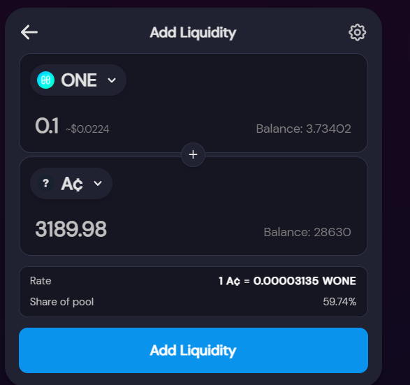

[PS: YOU CAN GET FREE ONE TO EXCHANGE INTO CREDITS THROUGH HARMONY FAUCET](https://harmony.supply/)  
  
Step 6: Physical Currency

While Almendria currently does not have physical currency, there are coins being planned, including nickel, plastic, gold, and silver coins.

They shall be exchangeable at the Bank of Almendria (BoA) for the following prices.

Almendrian physical currency shall be known as the Revcoin, standing for Revolution Coin.

| RevCoins made out of any other materials | 100 Credits |
| --- | --- |
| Plastic Almendrian RevCoin | 1000 Credits |
| Nickel Almendrian RevCoin | 10000 Credits |
| Silver Almendrian RevCoin | 50000 Credits |
| Gold Almendrian RevCoin | 100000 Credits |

**ALONG WITH AN INITIAL 100.000 CREDITS MINTED, ANY FURTHER CREDITS MUST ONLY BE MINTED WITH AN EQUIVALENT MINTING OF REVCOINS.**